Natural Mortality Rates for the Pacific Blue Marlin Stock

Jon Brodziak*

*NOAA Fisheries
Pacific Islands Fisheries Science Center
1845 Wasp Boulevard, Honolulu, HI 96818, USA

Email: Jon.Brodziak@NOAA.GOV



Abstract

Pacific blue marlin (Makaira nigricans) life-history inputs, particularly age and growth, remain a key source of uncertainty in Pacific-wide stock assessment advice. In the 2021 ISC assessment, the Billfish Working Group could not reach agreement between an “old” and a “new” growth curve. These alternatives differed in functional form and in sensitive parameters such as$L_{∞}$. The assessment therefore advanced an equally weighted two-model ensemble and explicitly noted substantial uncertainty in life-history parameters, especially growth. Despite this uncertainty, the 2021 ensemble indicated the stock was likely not overfished and very likely not experiencing overfishing relative to MSY-based reference points. For example, the assessment reported an estimated probability of about 81% that the stock was not overfished and greater than 90% that overfishing was not occurring in 2019.

This working paper updates sex- and age-specific natural mortality M for Pacific blue marlin. First, it develops an alternative estimator based on the Hamel and Cope (2022) maximum-age approach with Lorenzen rescaling. Both approaches are implemented using the new two-stanza growth model (TSGM) with age-determination uncertainty developed by Chang et al. (2025). Second, it revises the Brodziak (2021) meta-analysis framework, which combines multiple adult M estimators and rescales juvenile M using the Lorenzen allometric relationship.,

The Chang et al. (2025) TSGM was fit in a Bayesian errors-in-variables framework and better captures late-age growth than a von Bertalanffy curve. The intent is for this TSGM to supplant the growth model options used in the 2021 assessment ensemble. Using this updated growth model, the Lorenzen-scaled maximum-age estimator and the revised meta-analysis yield different point estimates for adult female natural mortality (0.20 versus 0.24) and for adult males (0.30 versus 0.26). Adult female and male M estimates from the Lorenzen-scaled maximum-age approach are substantially more variable (CV approximately 33%) than the meta-analytic estimates (CV less than 5%). These results show how growth model choice and estimation approach affect sex-specific M and provide alternative natural mortality rates for future Pacific blue marlin assessments.

Introduction

Natural mortality at age (M-at-age) is a required biological input for Pacific blue marlin stock assessments because it directly affects estimates of productivity, spawning biomass, fishing mortality, and reference points. In the 2021 ISC benchmark assessment, major life history uncertainty centered on growth. The Billfish Working Group could not reject either an “old growth” or “new growth” curve, so it adopted an ensemble of two Stock Synthesis models that differed only by the assumed growth curve and averaged results across models. The ensemble indicated the stock was likely not overfished and very likely not subject to overfishing. Recent spawning biomass was estimated above SSBMSY and recent fishing mortality below FMSY, with an 81% probability of not being overfished and greater than 90% probability of not being subject to overfishing. The 2021 assessment also highlighted that growth uncertainty can propagate strongly into stock status and projections, and it conducted sensitivity analyses that included changes to natural mortality and growth-curve parameters.

Growth assumptions are central to M estimation for blue marlin because both life history meta-analysis methods and size-based scaling methods use growth to connect age, size, and survival. In the Brodziak (2021) working paper, growth parameters were explicitly treated as uncertain inputs in the adult-M meta-analysis weighting, and growth scenarios were used to generate sex-specific maturity-at-age and maximum-age ranges that influence M estimation. Growth is even more influential when constructing M-at-age schedules. Brodziak (2021) scaled juvenile mortality using a Lorenzen allometric relationship between mortality and body weight, so the implied juvenile-to-adult scaling depends on the weight-at-age trajectory implied by the assumed growth curve. The 2021 assessment similarly tied age-specific natural mortality schedules to each growth model, with distinct M-at-age patterns under the old and new growth configurations.

Recent work by Chang et al. (2025) provides substantial advances in both the data foundation and the statistical treatment of growth for Pacific blue marlin, particularly for the rapid juvenile growth phase. Chang et al. (2025) models growth using sex-specific von Bertalanffy and a two-stanza growth model (TSGM) that explicitly represents juvenile growth from age 0 to 1 with a Gompertz function and subadult to adult growth with a Schnute function, using age 1 as the transition point based on exploratory analysis. The analysis incorporates an errors-in-variables framework for both length observation error and age determination error, and it estimates parameters using Bayesian MCMC (WinBUGS) with multiple chains and convergence checks. The study also documents improved ageing procedures and diagnostics for fin spine readings, including replicated reads, bias checks, and marginal increment ratio analyses, which help support more reliable estimates of size-at-age and longevity. Because the 2021 assessment’s new growth model was an interim two-stanza representation that differed substantially from the old growth model (including asymptotic length and functional form), and because growth uncertainty was a key unresolved issue, the Chang et al. (2025) TSGM provides a natural successor for updating growth-dependent assessment inputs, including M-at-age.

Advances in natural mortality estimation also motivate an update. First, Hamel and Cope (2022) refined maximum-age-based estimation by proposing an updated relationship between maximum age and M and by developing a tighter, more risk-neutral prior for assessment use. They emphasized that M is difficult to estimate and is affected by factors such as ageing error, and they proposed a lognormal prior with median proportional to 5.40/Amax and a reduced log-space standard deviation of 0.31, compared to an earlier maximum-age prior with standard deviation 0.51. This reduced variability is particularly relevant when propagating uncertainty into sex-specific adult M and into M-at-age schedules. Second, Brodziak (2021) combined multiple life-history-based estimators using fixed and random effects meta-analysis, then extended adult-M estimates to age-0 using Lorenzen weight-based scaling, producing sex-specific M-at-age schedules under alternative growth scenarios.

Finally, the theoretical and empirical basis for Lorenzen-style scaling has strengthened. Lorenzen (2022) synthesizes evidence supporting generalized length-inverse mortality as a within-population pattern (approximately c = -1), clarifies how density dependence and senescence can modify the pattern at small juvenile sizes and large old ages, and emphasizes the importance of distinguishing within-population scaling from community-level patterns that can yield misleading exponents. Lorenzen (2022) also notes that age-based implementations of allometric mortality models are typically obtained by converting size-based models to age using a growth function, reinforcing why updated growth curves, especially for rapid juvenile growth, are critical when applying Lorenzen rescaling to construct M-at-age schedules.

In this context, the goals of the present working paper are to update sex-specific natural mortality schedules for Pacific blue marlin using the Chang et al. (2025) growth model and to compare two primary estimation approaches. The first approach develops sex-specific M-at-age using the Hamel and Cope (2022) maximum-age estimator paired with Lorenzen weight-based rescaling, leveraging improved maximum-age-based theory and improved size-dependent mortality foundations. The second approach updates Brodziak (2021) style adult-M meta-analysis and juvenile scaling using the Chang et al. (2025) TSGM to generate revised M-at-age by sex. Together, these approaches address a key life-history uncertainty highlighted in the 2021 assessment, namely growth, while providing a transparent comparison of updated meta-analytic and maximum-age-based pathways for constructing M-at-age inputs for future Pacific blue marlin assessments.

Methods
Growth inputs
Chang et al. (2025) estimated growth using juvenile daily-age information from otolith micro-increment counts and annual ages from fin spine sections for subadults and adults. For the juvenile phase, daily ages were confidently obtained for 13 of 25 juvenile otolith samples (115–152 cm EFL), with counts ranging from 213 to 349 days. These new samples were combined with ISC IBBS otolith-based daily-age data (Shimose et al. 2015) to form a combined otolith dataset (n = 40) spanning 26 to 349 days and 17.2 to 159.7 cm EFL. Chang et al. (2025) fit a juvenile growth curve to these daily-age data and reported no significant sex differences in length-at-age prior to age 1, so juvenile data were combined by sex in model fitting.

For older ages, Chang et al. (2025) used fin spine sections and summarized ageing precision using repeated reads by the same experienced reader. They evaluated annulus periodicity using marginal increment ratio analysis. In the Taiwan-based spine dataset, 504 spine sections were successfully interpreted, with readability rates of 83% for females and 80% for males.

Chang et al. (2025) compared a von Bertalanffy growth model (VBGM) and a two-stanza growth model (TSGM), and both models incorporated length observation error and age-determination error. Model selection was based on deviance information criterion (DIC), with the lowest DIC treated as the preferred Bayesian model among candidates.

The TSGM used a juvenile Gompertz component for age 0 and a Schnute component for ages greater than age 0, with age 1 selected as the transition point based on exploratory analysis. In Chang et al. (2025), the adult component was applied over ages 1–27 for females and 1–18 for males, which define the sex-specific terminal ages used in the model. Parameter estimation was conducted using Bayesian MCMC (WinBUGS) with multiple chains and standard convergence diagnostics.

The TSGM equations for length L at age t can be written as:
Juvenile stage (Gompertz):

(1) $L\left(t\right)={f_{1}\left(t\right)=β}_{1}∙exp\left(-β_{2}∙exp\left(-β_{3}∙t\right)\right) for t∈(0,1]$

Subadult and adult stage (Schnute 1981, Case 2), for (t > 1):

(2) $L\left(t\right)={f_{2}\left(t\right)=L}_{1}∙exp\left[log\left(\frac{L_{2}}{L_{1}}\right)\frac{1-exp\left(-c∙\left(t-t_{1}\right)\right)}{1-exp\left(-c∙\left(t_{2}-t_{1}\right)\right)}\right] for t>1$
where t₁ = 1, L₁= f₁ (t₁), and t₂ is sex-specific (27 for females; 18 for males in Chang et al. 2025).

Chang et al. (2025) report posterior distributions for both VBGM and TSGM parameters by sex and show that the TSGM provides a better fit at older ages by capturing continued increases in length with age (Table 1). They also report that the otolith-derived EFL-at-age one estimate closely matches the TSGM prediction, supporting the juvenile component and the transition at age 1. Posterior summaries for the TSGM include sex-specific values for L₂ (length at (t₂)) and the Schnute shape parameter, along with age-determination error standard deviations by sex.

For estimating M-at-age by sex in this working paper, we used the Chang et al. (2025) TSGM as the growth foundation (Figures 1, 2 and 3). Specifically, we treated the sex-specific posterior mean TSGM parameters as fixed inputs to generate length-at-age and derived weight-at-age trajectories used in Lorenzen-style rescaling (Table 1). These growth inputs, together with the Lorenzen-scaled maximum age estimator, determine the implied M-at-age schedules because both maturity-at-age and size or weight at age depend directly on the assumed growth curve.
Length–weight conversion
Sex-specific length-weight parameters were used to convert modeled length-at-age, L(t), to weight-at-age, W(t), because both juvenile mortality scaling and Lorenzen size-based mortality depend on body mass. Weight at length was modeled using a power function,
(3) $W\left(L\left(t\right)\right)=A∙{L\left(t\right)}^{B}$
where A and B are sex-specific constants for Pacific blue marlin (Table 1, Figure 4).
Maturity and adult age threshold
Adult natural mortality is applied over an adult age window intended to represent ages at which fish are predominantly mature. In this paper, the adult threshold age is specified separately for females and males and defines the age range used to anchor the rescaled M(t) schedule to an adult target value. Because M(t) is derived from size- or weight-based scaling, shifting the anchoring window earlier or later changes the overall level of M across ages, including juvenile ages that are subsequently scaled from adult values.
As a baseline, we used adult ages of 4 years for females and 1 year for males, consistent with Brodziak (2021). This sex-specific definition reflects strong dimorphism in growth and maturation and implies that the anchoring window differs by sex. With the TSGM, a fixed age threshold can correspond to a different maturity state because length-at-age changes.
We also examined maturity-based adult thresholds using sex-specific maturity ogives. Probability of maturity at length is modeled with a logistic curve,
(4) $P_{mature}\left(L\right)={\left(1+exp⁡(s(L-L_{50})\right)}^{-1}$
where $L_{50}$ is length at 50% maturity and $s$ is the slope (Table 1, Figure 5). We mapped $L_{50}$ and $L_{95}$ to ages using the growth curve to obtain $A_{50}$ and $A_{95}$, which define alternative adult thresholds that are consistent with the updated growth inputs.
Because female and male blue marlin differ in growth and maturation, the adult window interacts with the growth curve in a sex-specific way. Anchoring M(t) using fixed ages (4 years for females; 1 year for males) versus maturity-based ages $A_{50}$ or $A_{95}$ can therefore produce different overall levels and shapes of M-at-age, especially when juvenile M is scaled from adult values using weight-based relationships. A sensitivity analysis to measure the effects of using $A_{50}$ or $A_{95}$ to set the adult window was conducted.
Maximum age inputs
Sex-specific longevity is required to apply the Hamel and Cope (2022) maximum-age estimator for adult natural mortality. In this approach, the maximum age $t_{max}$ is treated as an estimate of longevity (a.k.a., $A_{max}$) and it defines the adult natural mortality target used to anchor the sex-specific M-at-age schedule.
Hamel and Cope (2022) propose a one-parameter relationship between natural mortality and maximum age, fit in log-scale. The point estimate is expressed as:
(5) $M_{adult}={5.40}/{t_{max}}$
They define this point estimate as the median of the resulting prior on M, rather than the mean, to provide a risk-neutral estimate for stock assessment applications.
Hamel and Cope (2022) further recommend treating uncertainty in M given $t_{max}$ using a lognormal distribution. They report a natural log-space residual standard deviation of 0.44 around the fitted relationship and, to better represent the expected variability in true M given imperfect estimates of both M and $t_{max}$, they assume half of the observed variance reflects error in the M values used in the meta-analysis database. This yields a tighter lognormal prior with median (5.40/$t_{max}$and log-space standard deviation 0.31, replacing earlier maximum-age priors that were both lower and more variable (i.e., a median of 4.37/$t_{max}$ with log-space standard deviation 0.51 in Hamel (2015)).
For Pacific blue marlin, $t_{max}$was specified separately for females and males based on the maximum observed ages reported in Chang et al. (2025). These were (Table 1): female $t_{max}$=27 and male $t_{max}$=18. These sex-specific $t_{max}$ values determine sex-specific adult mortality targets through the Hamel and Cope relationship above.

Lorenzen-Scaled Maximum Age Estimator of Natural Mortality

This approach constructs a complete sex-specific M-at-age schedule by combining (i) a size-based Lorenzen mortality curve derived from weight-at-age and (ii) an adult M target derived from longevity using the Hamel and Cope (2022) maximum-age estimator. The key idea is that growth determines weight-at-age, weight-at-age determines the shape of the Lorenzen curve, and longevity determines the level of adult natural mortality used to anchor that curve.

Size at age was calculated on a quarterly basis to capture rapid changes in juvenile length and weight. For each sex, length-at-age L(t) is generated from the TSGM and then converted to weight-at-age using the sex-specific length–weight relationship (Figure 6).

Raw Lorenzen natural mortality at age was computed from an allometric mortality–weight relationship using the oceanic exponent (Lorenzen 1996). Using the two-stanza growth model, this can be written as

(6) $M_{w}(t)=M_{u}∙{W\left(L\left(t\right)\right)}^{b}=3.69∙{W\left(f_{1}\left(t\right)\right)}^{-0.305} for t∈(0,1]$

(7) $M_{w}(t)=M_{u}∙{W\left(L\left(t\right)\right)}^{b}=3.69∙{W\left(f_{2}\left(t\right)\right)}^{-0.305} for t>1$

These equations define the unscaled age-based mortality pattern implied by body size and produce higher mortality at small juvenile weights and lower mortality at larger adult weights.

The raw Lorenzen curve $M_{w}(t)$ was next anchored to an adult natural mortality target, $M_{adult}(t)$, that is computed separately for each sex from maximum age $t_{max}$ using the Hamel and Cope (2022) maximum-age estimator.

To ensure consistency with this adult target, the raw Lorenzen curve was rescaled over an adult anchoring window defined by the sex-specific adult threshold age (t_{c}), which can be set to a fixed adult age (Table 1) or a maturity-ogive based threshold. A simple rescaling based on the Lorenzen weights at adult ages is

(8) $M\left(t\right)=M_{adult}\frac{nM_{w}(t)}{\sum_{t=t_{c}}^{t_{max}}{M_{w}(t)}}$

This rescaling preserves the Lorenzen-derived shape of M(t) across ages while adjusting its overall level so that average adult M matches the longevity-based target (Porch 2011).

Uncertainty in M(t) was represented by treating each rescaled M(t) value as the median of a lognormal distribution with a fixed log-scale standard deviation. This assumption provided a consistent way to compute an 80% interval at each age and to convert that interval into an implied age-specific standard deviation. The resulting uncertainty was applied multiplicatively and scales with the magnitude of M(t).

Because M at age 0 was not directly included in the adult anchoring step, M₀ was derived from the ratio of early-life mean weights implied by the growth and length–weight inputs as

(9) $M_{0}=v∙M_{1}$

where the scaling factor $v$ was computed from the ratio of mean weights over the age intervals [0,1] and [1,2], raised to the Lorenzen oceanic exponent (-0.305), using a fine age mesh (i.e., h=0.01) to approximate the mean weights.

(10) $\text{v}=(E[W_{0-1}]/E[W_{1-2}]])^{-0.305}$

An approximate standard deviation for age 0 was obtained by scaling the age-1 standard deviation by the same ratio M₀ /M₁.

This approach used sex-specific weight-at-age to generate sex-specific juvenile scaling. This made the age-0 mortality estimate directly responsive to sexually dimorphic growth and to updates in the juvenile growth component of the two-stanza model.

Sensitivity to maturity-ogive based adult window

We conducted a sensitivity analysis to compare the results from the baseline adult anchoring windows (female $t_{c}=4$; male $t_{c}=1$) to maturity-based windows that start at $t_{c}=A_{50}$and $t_{c}=A_{50}$.

Updated meta-analysis using Chang et al. (2025) growth
Brodziak (2021) refined a meta-analytic framework estimate sex- and age-specific natural mortality for the Pacific blue marlin stock assessment (Lee and Chang 2013). The central challenge was that commonly used adult natural-mortality estimators produced divergent results, and those results shifted when alternative sex-specific growth scenarios were assumed. Brodziak (2021) addressed this by screening candidate adult-M estimators for credibility, quantifying within-estimator uncertainty from life-history inputs, combining retained estimators with meta-analysis, and then scaling adult M to calculate M₀ values using a Lorenzen weight-based relationship.
For model selection, Brodziak (2021) considered fourteen candidate methods for adult M and eliminated seven as non-credible under the old-growth scenario because they were redundant with other estimators or yielded implausible outcomes, including predicted female M values that implied unrealistically low survival to maximum age. The seven remaining plausible estimators were then carried forward unchanged under both growth scenarios so that differences in estimated M reflected growth assumptions rather than changes in the estimator set.
Within-estimator variability was quantified by propagating uncertainty in the life-history inputs required by each estimator. In particular, Brodziak (2021) set ranges for key growth parameters as mean ± one standard error for each growth scenario, derived maturity-at-age from growth and maturity-at-length by sex, and treated other supporting inputs (maximum age, temperature, and sex-specific length–weight parameters) as uncertain within stated ranges. These within-estimator variances became the precision weights used in the meta-analysis, so estimators with less uncertainty contributed more heavily to the pooled adult M estimate.
To combine estimators, both fixed-effects and random-effects meta-analysis were applied. Under the old-growth scenario, the analysis found no detectable heterogeneity among the seven retained estimators, so fixed- and random-effects results coincided. Under the new-growth scenario, some heterogeneity was detected, but the random-effects estimate for adult female M was judged implausibly high. Brodziak (2021) therefore used fixed-effects meta-analysis to predict adult natural mortality for both sexes under both growth scenarios.
Several of the adult natural-mortality estimators evaluated by Brodziak (2021) depended directly on von Bertalanffy growth-model (VBGM) quantities, especially the Brody growth coefficient (k), asymptotic length (L∞), and a length-at-age-zero term (L₀, sometimes represented implicitly through t₀). Brodziak (2021) explicitly treated the growth parameters of asymptotic length, Brody growth coefficient, and age-0 length as key uncertain inputs for the within-estimator variances used in the meta-analyses. In addition, the set of candidate adult-M methods in that study included multiple approaches that related natural mortality to the Brody growth parameter and to asymptotic length, among other life-history correlates.
In this working paper, growth and age inputs were updated to reflect the TSGM (Table 2 and 3). Because the TSGM does not estimate a single VBGM for the full life history, VBGM-style parameters required by some of the natural mortality estimators were derived as approximations from the adult portion of the TSGM curve.
To obtain sex-specific VBGM parameters for use in VBGM-dependent adult-M estimators, we fit a von Bertalanffy curve to the adult portion of the deterministic TSGM median length-at-age curve. A fixed TSGM adult Schnute curve was generated using the posterior medians for each sex (Tables 2 and 3). These were: female L₁ = 150.8, L₂ = 267.2, c = 0.24, t₁ = 1, t₂ = 27; male: L₁ = 148.2, L₂ = 198.6, c = 0.23, t₁ = 1, t₂ = 18). The adult fitting window was aligned with the adult-age cutoffs of age 4 for females and age 1 for males, and enforcing adult age ≥ 1 because the adult Schnute stanza begins at age 1. Length-at-age points were computed on a dense age grid (0.1 y spacing) over the adult domain, and a VB curve was fit to those points. We used the standard VB form with a free t0 parameter and estimated (L∞, k, t₀) by nonlinear least squares. This produced the following sex-specific VBGM parameters: female L∞ = 267.8, k = 0.22, t₀ = -2.29; male L∞ = 200.3, k = 0.21, t₀ = -5.40. The VBGM parameters were fit to the median lengths at age predicted from the TSGM using nonlinear regression with t₀ freely estimated, which provided an accurate VBGM approximation of the TSGM growth curve (Figure 7).

Given the VBGM parameters, the updated meta-analysis estimated sex- and age-specific natural mortality by applying the Brodziak (2021) meta analytic approach. It assigned within-estimator uncertainty from assumed ranges for key life-history inputs such as growth, maturity, maximum age, and temperature (Tables 2 and 3), propagated that uncertainty through each adult M estimator to obtain estimator-specific variances, and then pooled adult M across estimators using inverse-variance weighting under fixed-effects and random-effects formulations, with the same heterogeneity decision rule that sets the between-estimator variance to zero when heterogeneity is not supported. Those pooled adult M estimates were then converted to M-at-age via Lorenzen scaling, updated only by substituting TSGM-based weight-at-age with length–weight to define juvenile scaling including the age-0 to age-1 ratio while retaining sex-specific juvenile assumptions and maturity-based transition to adult M. In sum, the analysis followed the same Brodziak (2021) meta analysis the approximated von Bertalanffy growth parameters and maximum observed ages while updating the growth-driven weight-at-age inputs used to shape M-at-age.

Results

Lorenzen-scaled maximum age approach

The Lorenzen-scaled maximum-age approach produced a smoother, gradually declining $M(t)$ curve with slightly lower $M_{0}$compared to the 2021 meta-analyses and with higher variability for M-at-age (Table 4, Figure 8). The estimate of female adult natural mortality was $M_{adult}=0.20$(SD=0.07). Female natural mortality at age declined from $M_{0}=0.40$(SD=0.13) to $M_{1}=0.32$(SD=0.11), $M_{5}=0.23$(SD=0.08), and approaches 0.19 (SD=0.06) after age-13. Female M averaged 0.22 over all ages with a SD=0.05, and a range of 0.19 to 0.40.

Male M-at-age starts higher at $M_{0}=0.45$(SD=0.15) and then declines more modestly from $M_{1}=0.37$ (SD=0.12) toward $≈0.28$ (SD=0.09) by older ages (Table 4, Figure 8). The estimate of male adult natural mortality was $M_{adult}=0.30$(SD=0.10). Male M-at-age has a mean of 0.31 over all ages with a SD=0.04, and a range of 0.28–0.45.

Overall, the Lorenzen-scaled maximum-age produces M-at-age estimates similar to the 2021 meta analytic results based on the old growth model.

Updated meta-analysis approach

The updated meta-analytic schedule produced a peaked natural mortality pattern with a high age-0 value and then a nearly flat adult plateau by sex (Table 5, Figure 9). The estimate of female adult natural mortality was $M_{adult}=0.24$(SD=0.01). Females have a high age-0 natural mortality of $M_{0}=0.97$(SD=0.04), which declines rapidly to values of $M_{1}=M_{2}=0.26$(SD=0.01) and $M_{3}=0.25$(SD=0.01) at ages 1 to 3. Female M averaged 0.27 over all ages with a SD=0.14, and a range of 0.24 to 0.97.

Male M-at-age showed the same pattern as female M-at-age (Table 5, Figure 9). The estimate of male adult natural mortality was $M_{adult}=0.26$(SD=0.01). Based on the assumption of no sexual dimorphism at age-0, the male value of age-0 was $M_{0}=0.97$(SD=0.04) followed by an essentially constant M-at-age $M_{a}=0.26$(SD=0.01) for ages 1–18. Male M-at-age had a mean of 0.30 over all ages with a SD=0.16 and a range of 0.26–0.97. Overall, the meta-analytic update implied high age-0 natural mortality but minimal age-structure in the adult natural mortality within each sex.

Comparison of meta-analysis and Lorenzen-scaled maximum age approaches
Natural mortality estimates from the meta analysis and Lorenzen-scaled maximum age estimator differ for both sexes. Natural mortality at age-0 is much higher under the meta analytic approach than under the Lorenzen-scaled maximum age approach (Figure 10). For females, natural mortality estimates for age-1 and older under the meta analytic approach are higher than under the Lorenzen-scaled maximum age approach (Figure 11). In comparison, the adult female adult natural mortality rate decreases from 0.24 under the meta-analytic update to 0.20 under the Lorenzen-scaled maximum age (-17%). In contrast, male natural mortality estimates for age-1 and older under the meta analytic approach are lower than under the Lorenzen-scaled maximum age approach (Figure 11). The adult male level increases from 0.26 for the meta analysis to about 0.30 under the Lorenzen-scaled maximum age (+15%). As a result, both adult female and male M-at-age estimates differ in magnitude between the two methods.
Uncertainty in adult $M$ is substantially lower under the meta-analytic update than under the maximum-age approach (Figures 8 and 9), particularly in relative terms (CVs). Under the meta-analysis, adult SDs are about 0.01 for both sexes, implying adult CVs near 4%. Under the maximum-age approach, adult SDs are much larger, with examples at the adult window ages of roughly 0.08 for females at age 4 and 0.11 for males at the adult level, corresponding to CVs of about 32% and 34%, respectively. In short, the Lorenzen-scaled maximum-age approach propagates substantially more uncertainty into adult ages than the meta-analysis, especially for males.
Juvenile mortality differences are even more pronounced than adult differences, with the largest contrast occurring at age 0. The meta-analytic update sets $M_{0}=0.97$ for both sexes, while the maximum-age approach yields $M_{0}=0.40$for females and $M_{0}=0.45$for males, so males exceed females by 13% at age 0 under the maximum-age method. Relative to the meta-analytic $M_{0}$, the maximum-age $M_{0}$ values are lower by about 59% for females and 54% for males. Overall, the two approaches imply fundamentally different juvenile scaling behavior, with the maximum-age method producing much lower $M_{0}$ and introducing sex differences at age 0 that are absent under the meta-analytic update. Uncertainty was consistently larger under the maximum-age approach (higher CVs), reflecting higher variability from multiple inputs (e.g., $t_{max}$, growth/weight-at-age, and the adult age), whereas the meta-analysis reduced uncertainty based on the combination of multiple individual M estimators.

Comparison of current results to 2021 meta analyses

Relative to the 2021 stock-assessment meta-analytic schedules, the Chang et al. (2025)-based updates generally lower older-adult M-at-age (especially for males) while yielding age-0 mortality that is either comparable to 2021 under the maximum-age formulation or much higher under the updated meta-analysis. The comparison of estimates of natural mortality at age by sex show that the current analyses produce lower estimates of M-at-age for older adults by sex than the 2021 estimates (Tables 6 and 7). In contrast, the estimates of young of year age-0 mortality for the current estimates are similar to or higher than the 2021 estimates for females and males (Tables 6 and 7) Synthesizing across both 2021 scenarios, the current results imply adult female $M$ remains in roughly the same range as prior work (bounded by the two 2021 scenarios) while adult male $M$shifts downward under the current meta-analytic update and becomes method-dependent under the current max-age formulation. The current Lorenzen-scaled maximum-age track the 2021 juvenile scaling much more closely, especially for $M_{0}$, but they introduce substantially larger SDs at adult ages than the 2021 fixed-effects meta-analysis summaries making the current Lorenzen-scaled maximum-age approach closer in level to 2021 but less precise.

Sensitivity of M-at-age to maturity-ogive based adult window
Female Lorenzen rescaling is only weakly sensitive to shifting the adult age from the baseline age-4 threshold to maturity-based thresholds (Figure 12). When the adult window is shifted earlier using $A_{50}$ or slightly earlier using $A_{95}$, the rescaling constant changes only slightly, so the entire $M(t)$ vector is essentially a near-uniform perturbation: relative to baseline, female natural mortality values of $M_{0},M_{1},M_{5},M_{10},M_{15}$shift by about −1.5% under $A_{50}$ and about −0.5% under $A_{95}$, and the SDs move by essentially the same percentages. The practical conclusion is that, given the new growth inputs used here, female rescaled Lorenzen schedules are quantitatively robust to plausible maturity-based changes in setting the adult age.
Male age-window sensitivity is similarly small (Figure 12) because the baseline adult age is age-1 and the maturity-based thresholds implied by the growth–maturity mapping shift the window only modestly in relative terms, producing only small changes in the rescaling constant.
Switching the adult start year to $A_{50}$ or $A_{95}$ yields an almost uniform adjustment of the male vector. Relative to baseline, the sensitivity runs shift $M_{0},M_{1},M_{5},M_{10},M_{15}$ by about −0.8% with SDs changing by essentially the same proportion. The key takeaway is that the male rescaled Lorenzen schedule is also numerically stable to these anchoring-window alternatives, even though the male schedule itself remains higher and more uncertain than the female schedule under the maximum-age + Lorenzen approach.
Practically, that means (i) the rescaled Lorenzen maximum-age schedules in Tables 6–7 are not “fragile” to reasonable maturity-based re-definitions of adulthood, while (ii) the bigger modeling leverage still comes from the choice of approach (meta-analysis vs max-age + Lorenzen) and the underlying growth/longevity inputs that set the overall level and curvature of $M(t)$by sex.
Discussion
The Chang et al. (2025) TSGM growth update mainly affects the Lorenzen-scaled maximum-age approach because it links M(t) directly to weight-at-age. Under Lorenzen scaling, changes in early weight-at-age change the juvenile-to-adult contrast in M(t). Faster early growth and higher weight tends to reduce juvenile M(t) relative to adult M, while slower early growth tends to increase juvenile M(t). In contrast, the meta-analytic approach is estimate-driven and does not require an explicit growth-to-mortality mapping, so growth updates affect it mostly indirectly, for example, through maturity-based definitions of adult. Overall, the growth update reshapes the Lorenzen-scaled maximum-age schedule much more than the meta-analytic schedule.
Sex differences in longevity and growth inputs amplify these effects and explain why males diverge more between approaches. A shorter male lifespan implies higher average lifetime mortality to be consistent with the assumed maximum age, which pushes the Lorenzen-scaled maximum-age curve upward at adult ages and can steepen the decline from juvenile to adult mortality. Female longevity allows a lower adult level and a smoother decline once the curve is anchored, so female schedules tend to agree more closely across approaches. In short, the Lorenzen-scaled maximum-age method makes male estimates more sensitive to growth and longevity assumptions.
These same mechanisms also explain why sex differences are more pronounced under the Lorenzen-scaled maximum-age approach than under the meta-analytic update. With Lorenzen scaling applied to sex-specific growth and maximum age, males tend to have higher juvenile mortality at many ages, whereas the meta-analytic update enforces near-identical juvenile $M_{0}$ and relatively flat adult levels that limit age-specific curvature. The conclusion is that the growth update shows up most clearly through the Lorenzen-scaled maximum-age framework, especially for males. Changes in predicted weight at very young ages under Chang et al. (2025) shift the implied age-0 scaling and therefore change both $M_{0}$ and its SD=under each approach, with the largest effects occurring under the Lorenzen pathway. In the maximum-age + Lorenzen approach, $M_{0}$ is effectively determined by (i) the adult anchor and (ii) the relative weight-at-age at age 0 versus adult ages; therefore, even modest shifts in $W\left(0\right)$ can substantially change $M_{0}$. Because uncertainty in $M_{0}$ inherits uncertainty from the adult age and from the growth and weight inputs, the age-0 SD and CV can increase sharply under Lorenzen rescaling. In the current meta-analysis and the 2021 meta-analysis, $M_{0}$ uncertainty is driven more directly by the meta-analytic model and less by growth propagation, so juvenile SDs are typically smaller and less sensitive to the Chang et al. (2025) growth curve.
The age-0 results differ between meta analytic and Lorenzen approaches because $M_{0}$ in this framework is controlled by the age-0 scaling factor derived from juvenile weight trajectories and the Lorenzen exponent. In the maximum-age formulation, raw Lorenzen mortality is $M_{w}(t)=μ W(t)^{-0.305}$ while in the meta analytic formulation following Brodziak (2021), the ecosystems scaling of $M_{w}(t)=μ W(t)^{-0.288}$ was used. With the 2025 growth update, those different scalings yield $M_{0}≈0.40$–0.45 in the Lorenzen maximum-age approach versus $M_{0}=0.97$in the meta-analytic update. This implies that the updated juvenile weight trajectory and how it is coupled to the rescaled curve changes the age-0 scaling and the implied SD at age-0.
For Pacific blue marlin stock assessment, the Lorenzen-scaled maximum-age approach provides a reasonable basis for constructing sex-specific M(t) inputs because it ties the adult level of mortality to longevity while allowing growth to determine the age pattern of mortality. Hamel and Cope (2022) emphasize that M is difficult to estimate directly and that maximum age provides a practical proxy for longevity, while also stressing that $t_{max}$must be evaluated carefully because sampling, selectivity, and ageing error can bias it downward and therefore bias longevity-based M upward. They also recommend representing uncertainty explicitly and treating M as lognormal and using the median as a risk-neutral point estimate. This is because both $t_{max}$ and meta-analytic databases contribute error. Complementing this, Then et al. (2015) found that a $t_{max}$based estimator performed best among the life-history predictors they compared, supporting maximum-age estimators as pragmatic, data-grounded inputs when direct information on M is weak.

A second reason to emphasize the Lorenzen-scaled maximum-age approach is that it aligns with a widely supported biological regularity. Mortality declines approximately with increasing size. Hoyle (2022) notes that $t_{max}$based estimators, including Then et al. (2015) and Hamel and Cope (2022) are useful for setting the level of M. He also recommends Lorenzen-style scaling as increasingly well established for representing M(t) rather than imposing step changes between juvenile and adult mortality. This matches the logic applied in the Lorenzen-scaled maximum-age approach. Longevity defines a sex-specific adult target, and the Lorenzen relationship shapes the curve using growth and weight before rescaling over an adult window. In contrast, the meta-analytic approach (Lee and Chang 2013; Brodziak 2021) is an ensemble of adult-M estimators that can yield stable point estimates, but meta analytic model averaging can also reduce apparent variability. This is consistent with the observation that model-averaged predictions can appear to have low variance even when underlying uncertainties are broader.
Suggested M-at-age inputs for the Pacific blue marlin assessment could include a clearly defined primary series and a structured sensitivity set, with documentation that emphasizes structural assumptions affecting M(t) rather than only differences in point estimates. One reasonable option is to use the Lorenzen-scaled maximum-age M(t) series as the default because it represents adult size dependence explicitly while anchoring the adult level to longevity. As sensitivities, it would be useful to retain the updated meta-analytic adult-M series as an alternative and to include maturity-based adult-threshold variants for both approaches to bracket sensitivity to how the adult window is defined. In documenting these choices, the main distinction is whether the adult natural mortality pattern has a size-dependent decline or is constant for all adult ages.

References
Brodziak, J. 2021. Natural mortality rates of Pacific blue marlin. PIFSC Working Paper No. WP-21-005; ISC/21/BILLWG-01/03. Pacific Islands Fisheries Science Center, National Marine Fisheries Service. https://doi.org/10.25923/hwy4-2767

Chang, Y.-J., Brodziak, J., Lee, H.-H., DiNardo, G., and Sun, C.-L. 2013. A Bayesian hierarchical meta-analysis of blue marlin (Makaira nigricans) growth in the Pacific Ocean. Working paper submitted to the ISC Billfish Working Group Workshop. 16-23 January, Honolulu, Hawaii, 23 p. Available at: http://isc.fra.go.jp/pdf/BILL/ISC13_BILL_1/ISC13BILLWG-1-02.pdf

Chang, Y.J., Shimose, T., Kanaiwa, M., Chang, X.B., Masubuchi, T., Yamamoto, A., Kanaiwa, M., 2020. Estimation of the two-stanza growth curves with ageing uncertainty for the Pacific blue marlin (Makaira nigricans). ISC/20/BILLWG-02/03.

Chang, Y.-J., Shimose, T., Chang, X.-B., Furuyama, A., Hsu, J., Kanaiwa, M., Chiang, W.-C., Brodziak, J. K. T., Kai, M., Ijima, H., Sculley, M. L., & Kinney, M. J. 2025. Estimation of the two-stanza growth curves with age determination uncertainty for Pacific blue marlin (Makaira nigricans) in the western and central North Pacific Ocean. ICES Journal of Marine Science, 82(8), fsaf134. https://doi.org/10.1093/icesjms/fsaf134

Hamel, O. S. 2015. A method for calculating a meta-analytical prior for the natural mortality rate using multiple life history correlates. ICES Journal of Marine Science, 72: 62–69. https://academic.oup.com/icesjms/article/72/1/62/2804304

Hamel, O. S., & Cope, J. M. 2022. Development and considerations for application of a longevity-based prior for the natural mortality rate. Fisheries Research, 256, 106477. https://doi.org/10.1016/j.fishres.2022.106477

Lee, H.-H. and Chang, Y.-J. 2013. Age-structure natural mortality for Pacific blue marlin based on meta-analysis and an ad hoc mortality model. Working paper submitted to the ISC Billfish Working Group Meeting, 16-23 January, Honolulu, Hawaii. ISC/13/BILLWG-1/07. Available at: http://isc.fra.go.jp/pdf/BILL/ISC13_BILL_1/ISC13BILLWG-1-07.pdf

Lorenzen, K. 1996. The relationship between body weight and natural mortality in juvenile and adult fish: A comparison of natural ecosystems and aquaculture. Journal of Fish Biology, 49, 627–647.

Lorenzen, K. 2022. Size- and age-dependent natural mortality in fish populations: Biology, models, implications, and a generalized length-inverse mortality paradigm. Fisheries Research, 255, 106454. https://doi.org/10.1016/j.fishres.2022.106454

Porch, C.E. 2011. Abstract #12: Rescaling the Lorenzen natural mortality curve: issues from the Southeast Data Assessment and Review. In: Brodziak J., Ianelli J., Lorenzen K., Methot Jr. R.D., eds. Estimating Natural Mortality in Stock Assessment Applications. Alaska Fisheries Science Center, Seattle, WA: National Oceanic and Atmospheric Administration. https://spo.nmfs.noaa.gov/sites/default/files/tm119.pdf

Then, A.Y., Hoenig, J.M., Hall, N.G., Hewitt, D.A. 2015. Evaluating the predictive performance of empirical estimators of natural mortality rate using information on over 200 fish species. ICES Journal of Marine Science. 72:82-92.

Schnute, J. 1981. A versatile growth model with statistically stable parameters. Canadian Journal of Fisheries and Aquatic Sciences, 38, 1128–1140. https://doi.org/10.1139/f81-153

Table 1. Pacific blue marlin parameters used in the Lorenzen-scaled maximum-age estimator.

Parameter | Female | Male
Juvenile growth $β_{1}$ | 151.6 | 148.9
Juvenile growth $β_{2}$ | 3.45 | 3.49
Juvenile growth $β_{3}$ | 6.44 | 6.70
Length at transition age $L_{1}$ | 150.8 | 148.2
Length at maximum adult age $L_{2}$ | 267.2 | 198.6
Schnute curve shape parameter c | 0.24 | 0.23
Transition age $t_{1}$ | 1 | 1
Maximum adult age $t_{2}$ | 27 | 18
Maximum age $t_{max}$ | 27 | 18
Adult age $t_{c}$ | 4 | 1
Length-weight scalar $A$ | 0.00001844 | 0.00001370
Length-weight exponent $B$ | 2.956 | 2.975
Maturity ogive slope s | 0.2039 | 22.6495
Length at 50% maturity $L_{50}$ | 179.8 | 130.0

Table 2. Female Pacific blue marlin parameters for the 2021 meta analysis update with Chang et al. (2025) parameters.

Parameter | Mean | Lower Bound | Upper Bound
Brody growth coefficient | 0.22 | 0.19 | 0.25
Asymptotic length | 268.0 | 261.0 | 275.0
Maturation length | 179.8 | 179.8 | 194.0
Maximum age | 27.0 | 24.0 | 30.0
Maturation age | 4.0 | 3.5 | 4.5
Age at length=0 | -4.71 | -5.21 | -4.21
Temperature | 25.5 | 24.0 | 27.0
Length-weight exponent | 2.956 | 2.956 | 2.956

Table 3. Male Pacific blue marlin parameters for the 2021 meta analysis update with Chang et al. (2025) parameters.

Parameter | Mean | Lower Bound | Upper Bound
Brody growth coefficient | 0.21 | 0.13 | 0.29
Asymptotic length | 200.0 | 194.0 | 206.0
Maturation length | 130.0 | 130.0 | 140.0
Maximum age | 18.0 | 16.0 | 20.0
Maturation age | 1.0 | 0.8 | 1.2
Age at length=0 | -5.4 | -6.0 | -4.8
Temperature | 25.5 | 24.0 | 27.0
Length-weight exponent | 2.975 | 2.975 | 2.975

Table 4. Natural mortality rate at age by sex results for the Pacific blue marlin Lorenzen-scaled maximum age estimator.

 | Natural Mortality Rate at Age |  | Standard Deviation
Age | Female | Male | Female | Male
0 | 0.40 | 0.45 | 0.13 | 0.15
1 | 0.32 | 0.37 | 0.11 | 0.12
2 | 0.29 | 0.35 | 0.10 | 0.12
3 | 0.26 | 0.33 | 0.09 | 0.11
4 | 0.25 | 0.32 | 0.08 | 0.11
5 | 0.23 | 0.31 | 0.08 | 0.10
6 | 0.22 | 0.30 | 0.07 | 0.10
7 | 0.22 | 0.30 | 0.07 | 0.10
8 | 0.21 | 0.29 | 0.07 | 0.10
9 | 0.21 | 0.29 | 0.07 | 0.10
10 | 0.20 | 0.29 | 0.07 | 0.10
11 | 0.20 | 0.29 | 0.07 | 0.10
12 | 0.20 | 0.29 | 0.07 | 0.10
13 | 0.20 | 0.28 | 0.07 | 0.09
14 | 0.19 | 0.28 | 0.06 | 0.09
15 | 0.19 | 0.28 | 0.06 | 0.09
16 | 0.19 | 0.28 | 0.06 | 0.09
17 | 0.19 | 0.28 | 0.06 | 0.09
18 | 0.19 | 0.28 | 0.06 | 0.09
19 | 0.19 |  | 0.06
20 | 0.19 |  | 0.06
21 | 0.19 |  | 0.06
22 | 0.19 |  | 0.06
23 | 0.19 |  | 0.06
24 | 0.19 |  | 0.06
25 | 0.19 |  | 0.06
26 | 0.19 |  | 0.06
27 | 0.19 |  | 0.06

Table 5. Natural mortality rate at age by sex results for the Pacific blue marlin updated meta analysis estimator.

 | Natural Mortality Rate at Age |  | Standard Deviation
Age | Female | Male | Female | Male
0 | 0.97 | 0.97 | 0.04 | 0.04
1 | 0.26 | 0.26 | 0.01 | 0.01
2 | 0.26 | 0.26 | 0.01 | 0.01
3 | 0.25 | 0.26 | 0.01 | 0.01
4 | 0.24 | 0.26 | 0.01 | 0.01
5 | 0.24 | 0.26 | 0.01 | 0.01
6 | 0.24 | 0.26 | 0.01 | 0.01
7 | 0.24 | 0.26 | 0.01 | 0.01
8 | 0.24 | 0.26 | 0.01 | 0.01
9 | 0.24 | 0.26 | 0.01 | 0.01
10 | 0.24 | 0.26 | 0.01 | 0.01
11 | 0.24 | 0.26 | 0.01 | 0.01
12 | 0.24 | 0.26 | 0.01 | 0.01
13 | 0.24 | 0.26 | 0.01 | 0.01
14 | 0.24 | 0.26 | 0.01 | 0.01
15 | 0.24 | 0.26 | 0.01 | 0.01
16 | 0.24 | 0.26 | 0.01 | 0.01
17 | 0.24 | 0.26 | 0.01 | 0.01
18 | 0.24 | 0.26 | 0.01 | 0.01
19 | 0.24 |  | 0.01
20 | 0.24 |  | 0.01
21 | 0.24 |  | 0.01
22 | 0.24 |  | 0.01
23 | 0.24 |  | 0.01
24 | 0.24 |  | 0.01
25 | 0.24 |  | 0.01
26 | 0.24 |  | 0.01
27 | 0.24 |  | 0.01

Table 6. Comparison of female natural mortality at age across Lorenzen-scale maximum age and current meta analytic (this working paper) and 2021 meta analytic estimators (Brodziak 2021) with SDs in parentheses.

Approach | Adult M | M0 | M1 | M5 | M10 | M15
Current meta-analytic update Chang et al. (2025) | 0.24 (0.01) | 0.97 (0.04) | 0.26 (0.01) | 0.24 (0.01) | 0.24 (0.01) | 0.24 (0.01)
Current Lorenzen max-age estimator Chang et al. (2025) | 0.20 (0.07) | 0.40 (0.13) | 0.32 (0.11) | 0.23 (0.08) | 0.20 (0.07) | 0.19 (0.06)
Brodziak (2021) meta-analysis, old growth Chang (2013) | 0.20 (0.01) | 0.43 (0.02) | 0.38 (0.02) | 0.20 (0.01) | 0.20 (0.01) | 0.20 (0.01)
Brodziak (2021) meta-analysis, new growth Chang et al. (2020) | 0.30 (0.01) | 0.40 (0.02) | 0.35 (0.02) | 0.30 (0.01) | 0.30 (0.01) | 0.30 (0.01)

Table 7. Comparison of male natural mortality at age across Lorenzen-scale maximum age and current meta analytic (this working paper) and 2021 meta analytic estimators (Brodziak 2021) with SDs in parentheses.

Approach | Adult M | M0 | M1 | M5 | M10 | M15
Current meta-analytic update Chang et al. (2025) | 0.26 (0.01) | 0.97 (0.04) | 0.26 (0.01) | 0.26 (0.01) | 0.26 (0.01) | 0.26 (0.01)
Current Lorenzen max-age estimator Chang et al. (2025) | 0.30 (0.10) | 0.45 (0.15) | 0.37 (0.12) | 0.31 (0.10) | 0.29 (0.10) | 0.28 (0.09)
Brodziak (2021) meta-analysis, old growth Chang (2013) | 0.38 (0.02) | 0.43 (0.02) | 0.38 (0.02) | 0.38 (0.02) | 0.38 (0.02) | 0.38 (0.02)
Brodziak (2021) meta-analysis, new growth Chang et al. (2020) | 0.35 (0.02) | 0.40 (0.02) | 0.35 (0.02) | 0.35 (0.02) | 0.35 (0.02) | 0.35 (0.02)

Figure 1. Pacific blue marlin length-at-age curves for age-0 to age-30 from Chang et al. (2025).
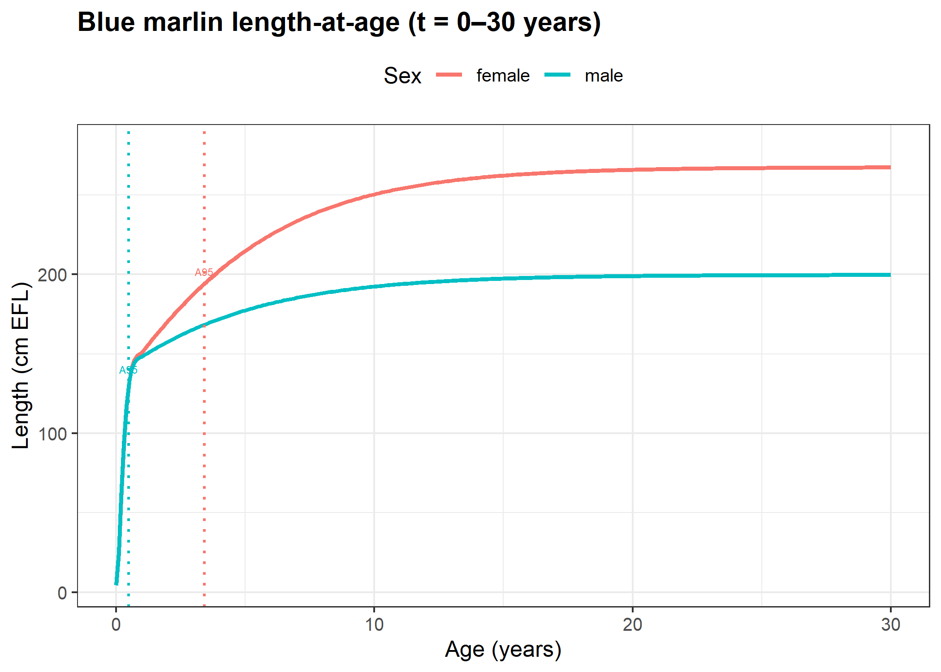

Figure 2. Pacific blue marlin length-at-age curves for age-1 to age-30 from Chang et al. (2025).
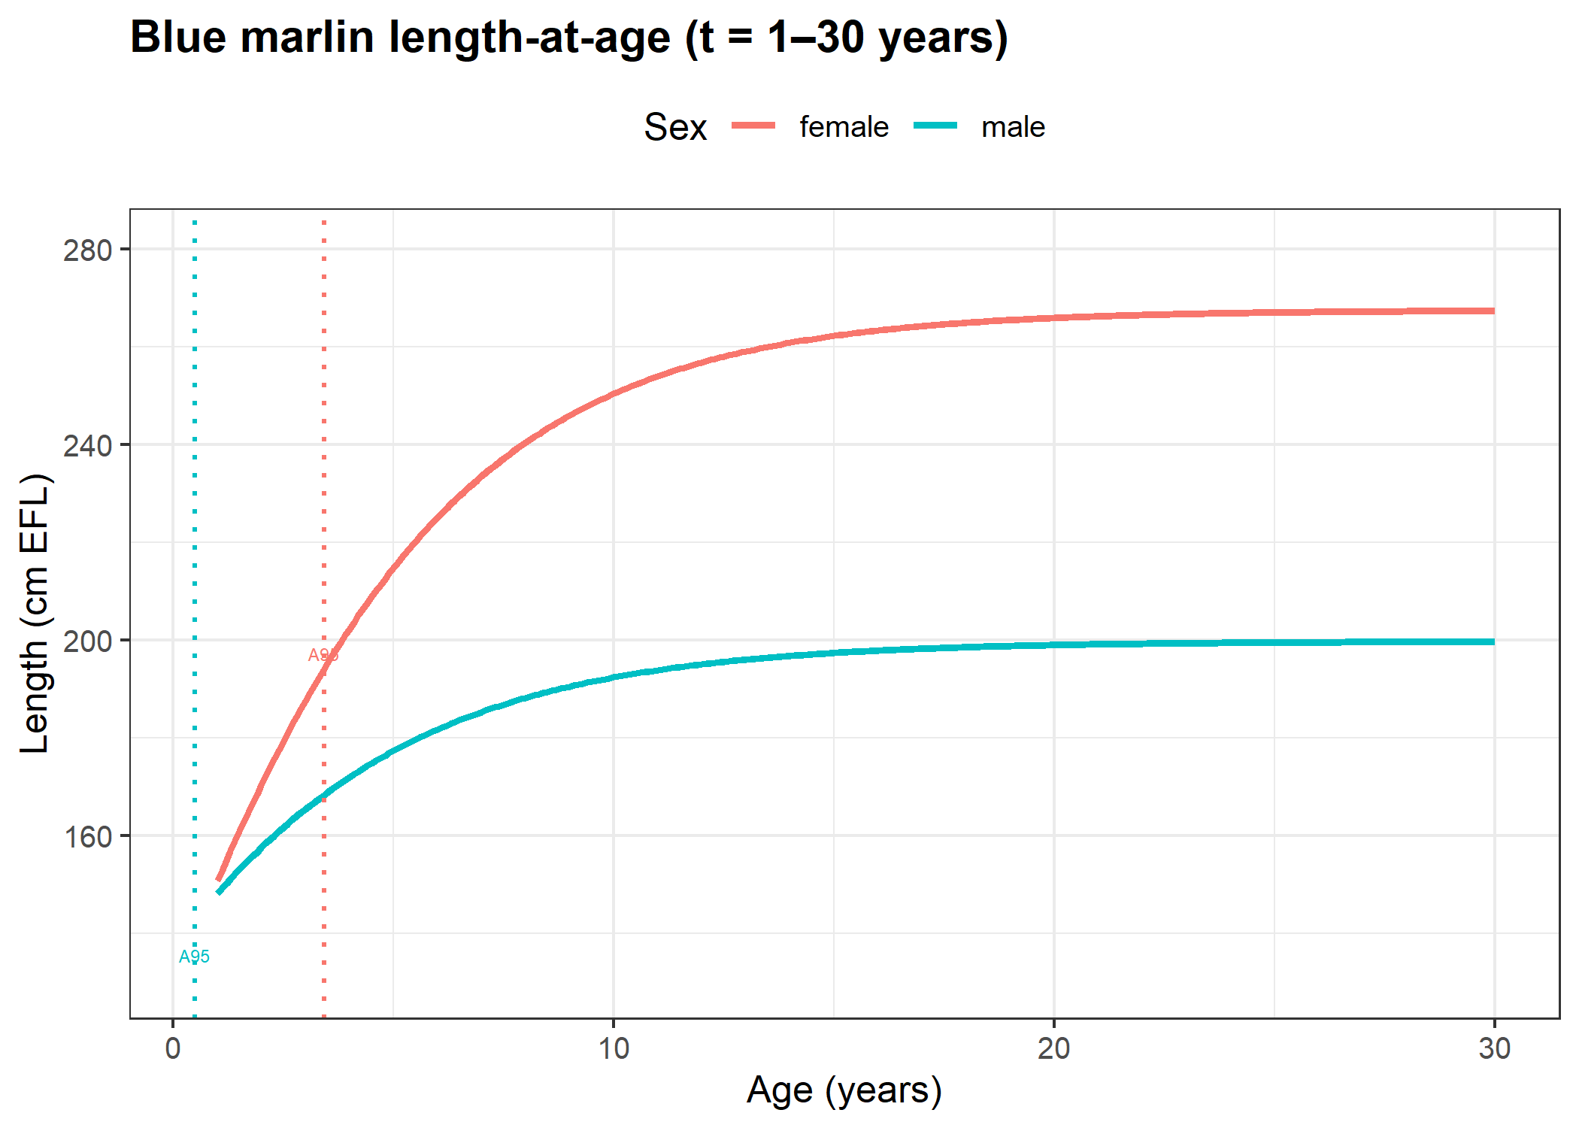

Figure 3. Pacific blue marlin length-at-age curves for ages less than 1 year from Chang et al. (2025).
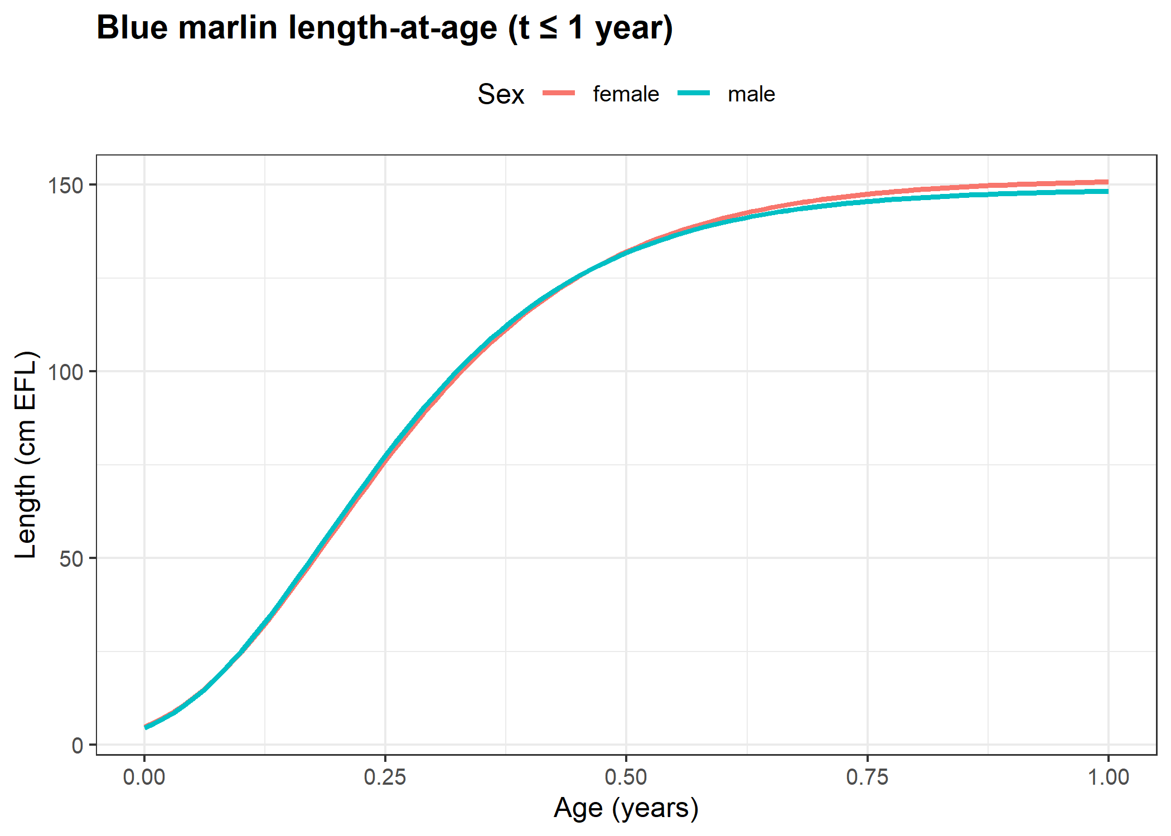

Figure 4. Pacific blue marlin weight-at-length curves used in 2021 stock assessment.
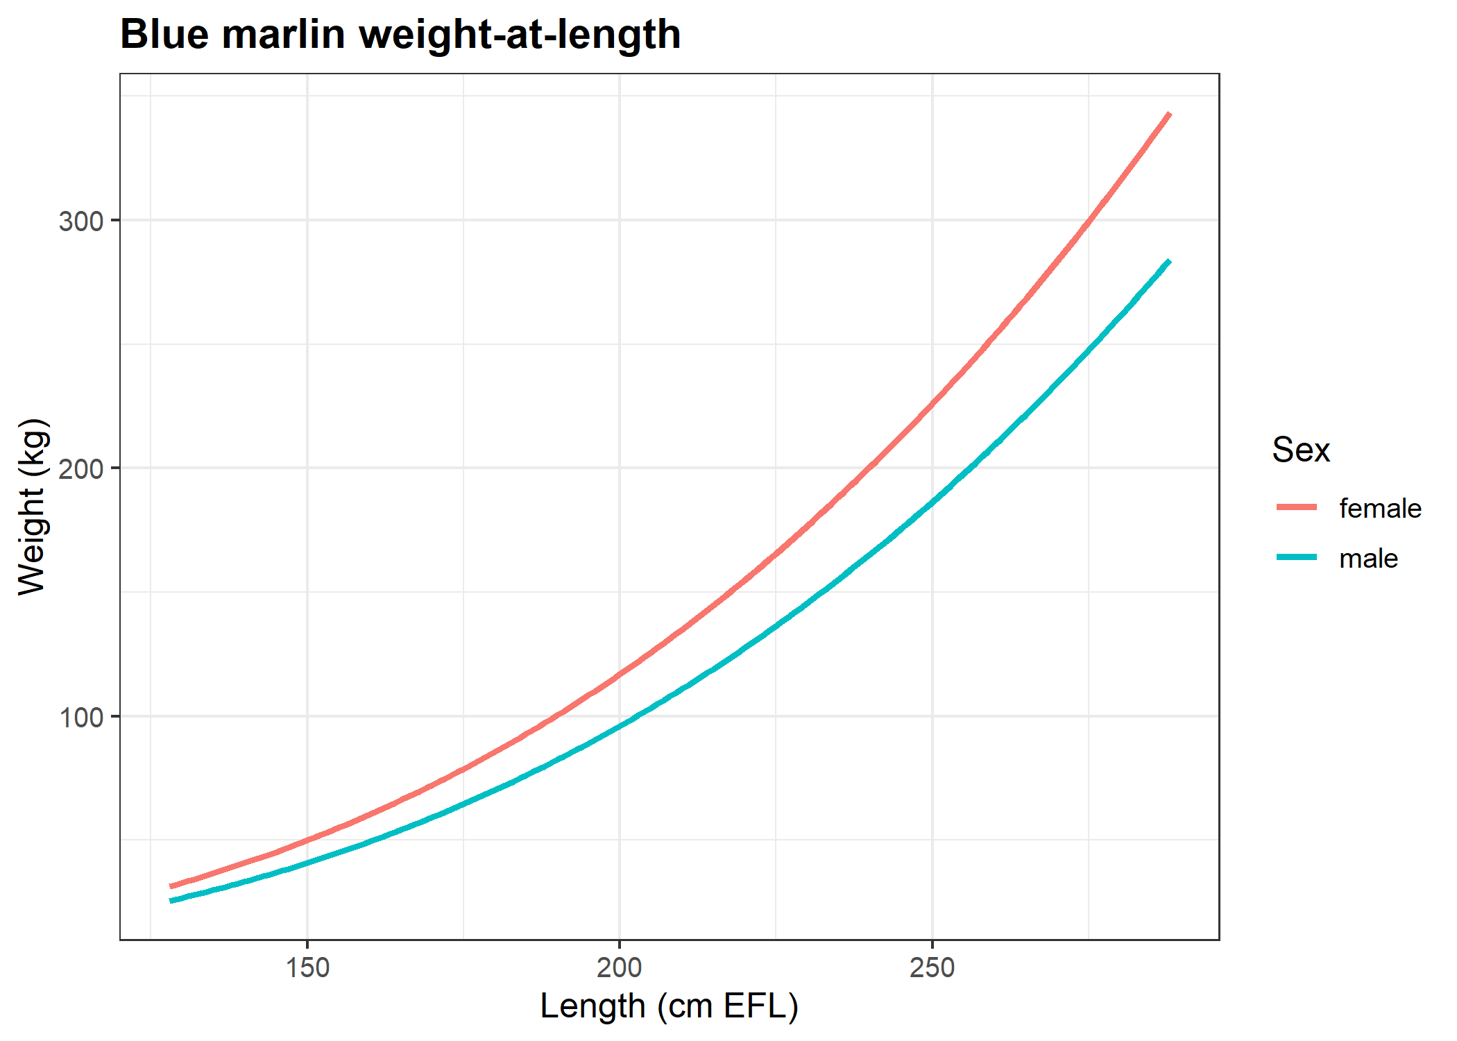

Figure 5. Pacific blue marlin maturity-at-length curves used in 2021 stock assessment.
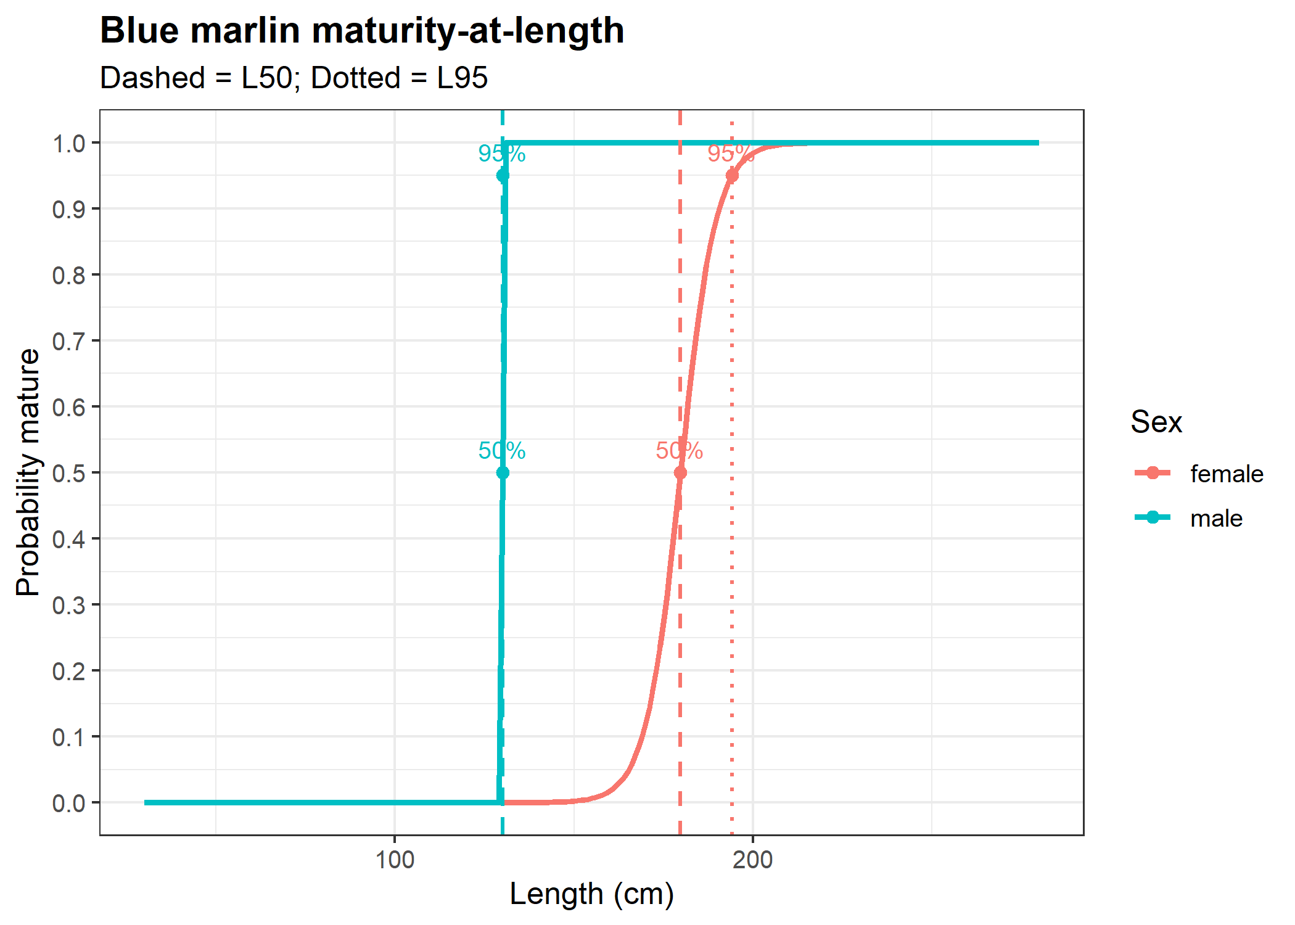

Figure 6. Pacific blue marlin weight-at-age curves used based on Chang et al. (2025).
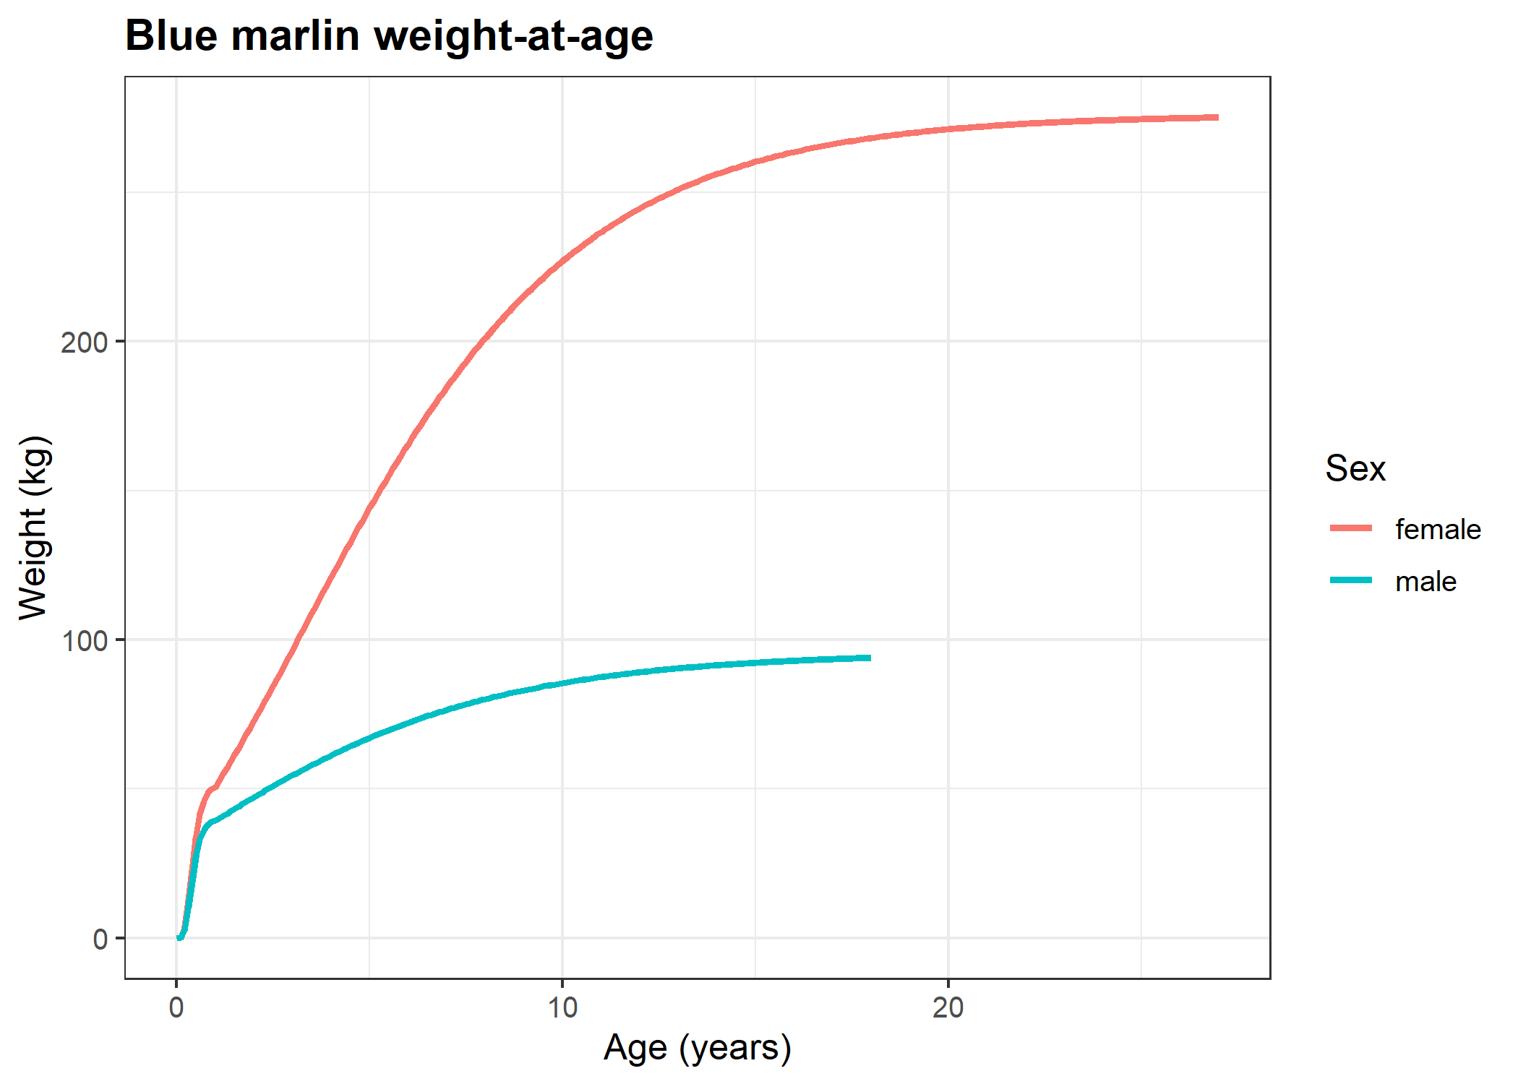

Figure 7. Comparison of two-stage growth and approximate von Bertalanffy growth models used for estimating meta analysis growth parameters.
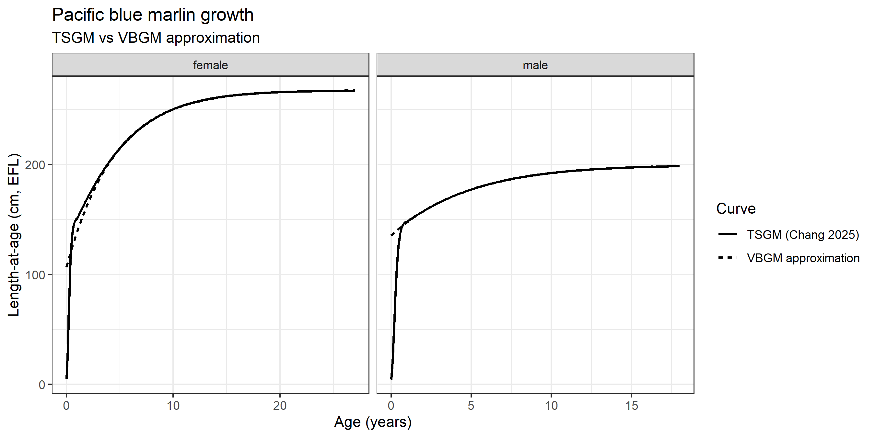

Figure 8. Lorenzen-scaled maximum age based estimates of natural mortality at age curves by sex for Pacific blue marlin with 80% confidence intervals.

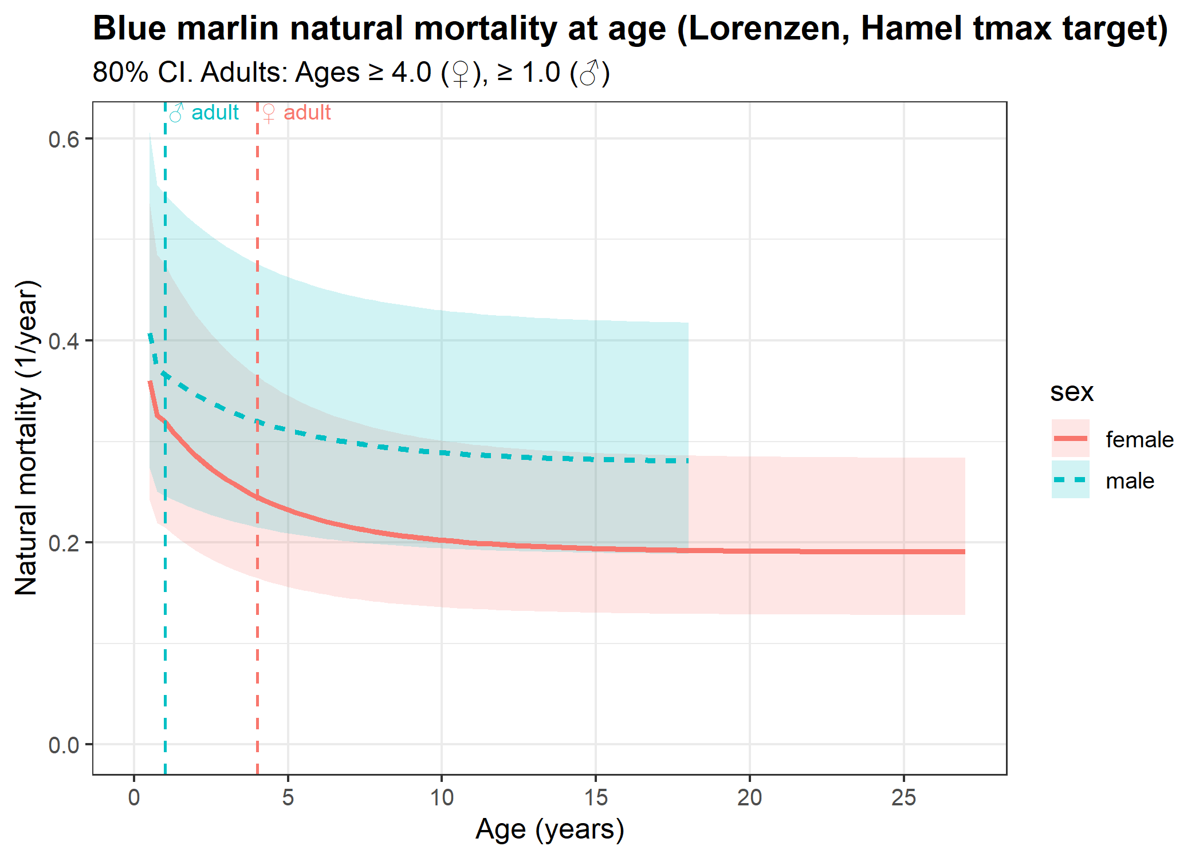

Figure 9. Meta analytic estimates of natural mortality at age curves by sex for Pacific blue marlin with 80% confidence intervals.
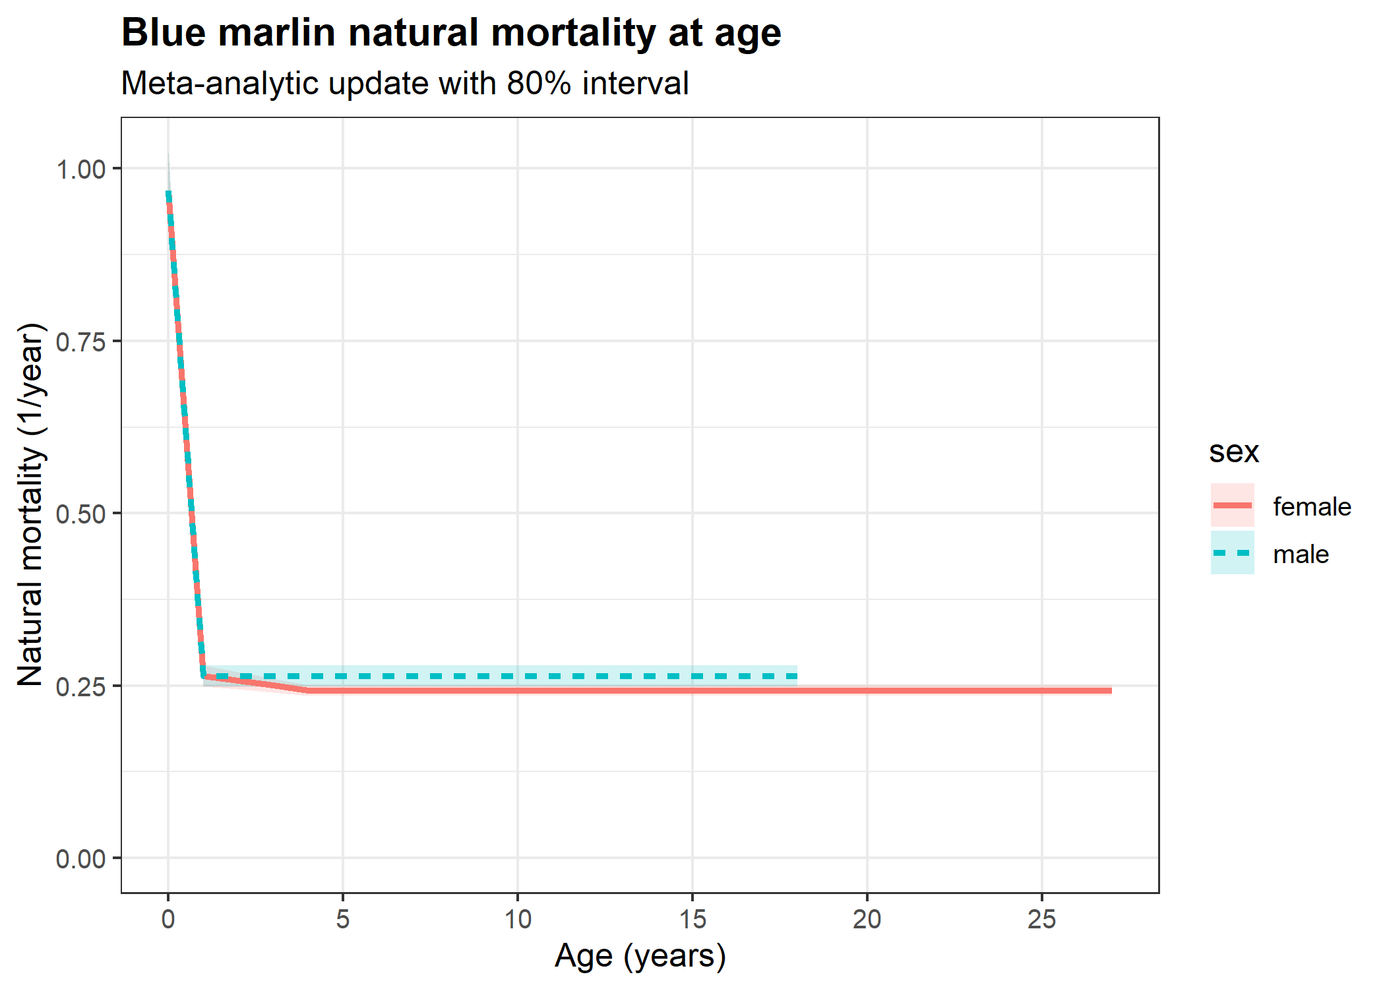

Figure 10. Comparison of Lorenzen-scaled maximum age based and meta analytic estimates of natural mortality at age-0 by sex for Pacific blue marlin with 80% confidence intervals.
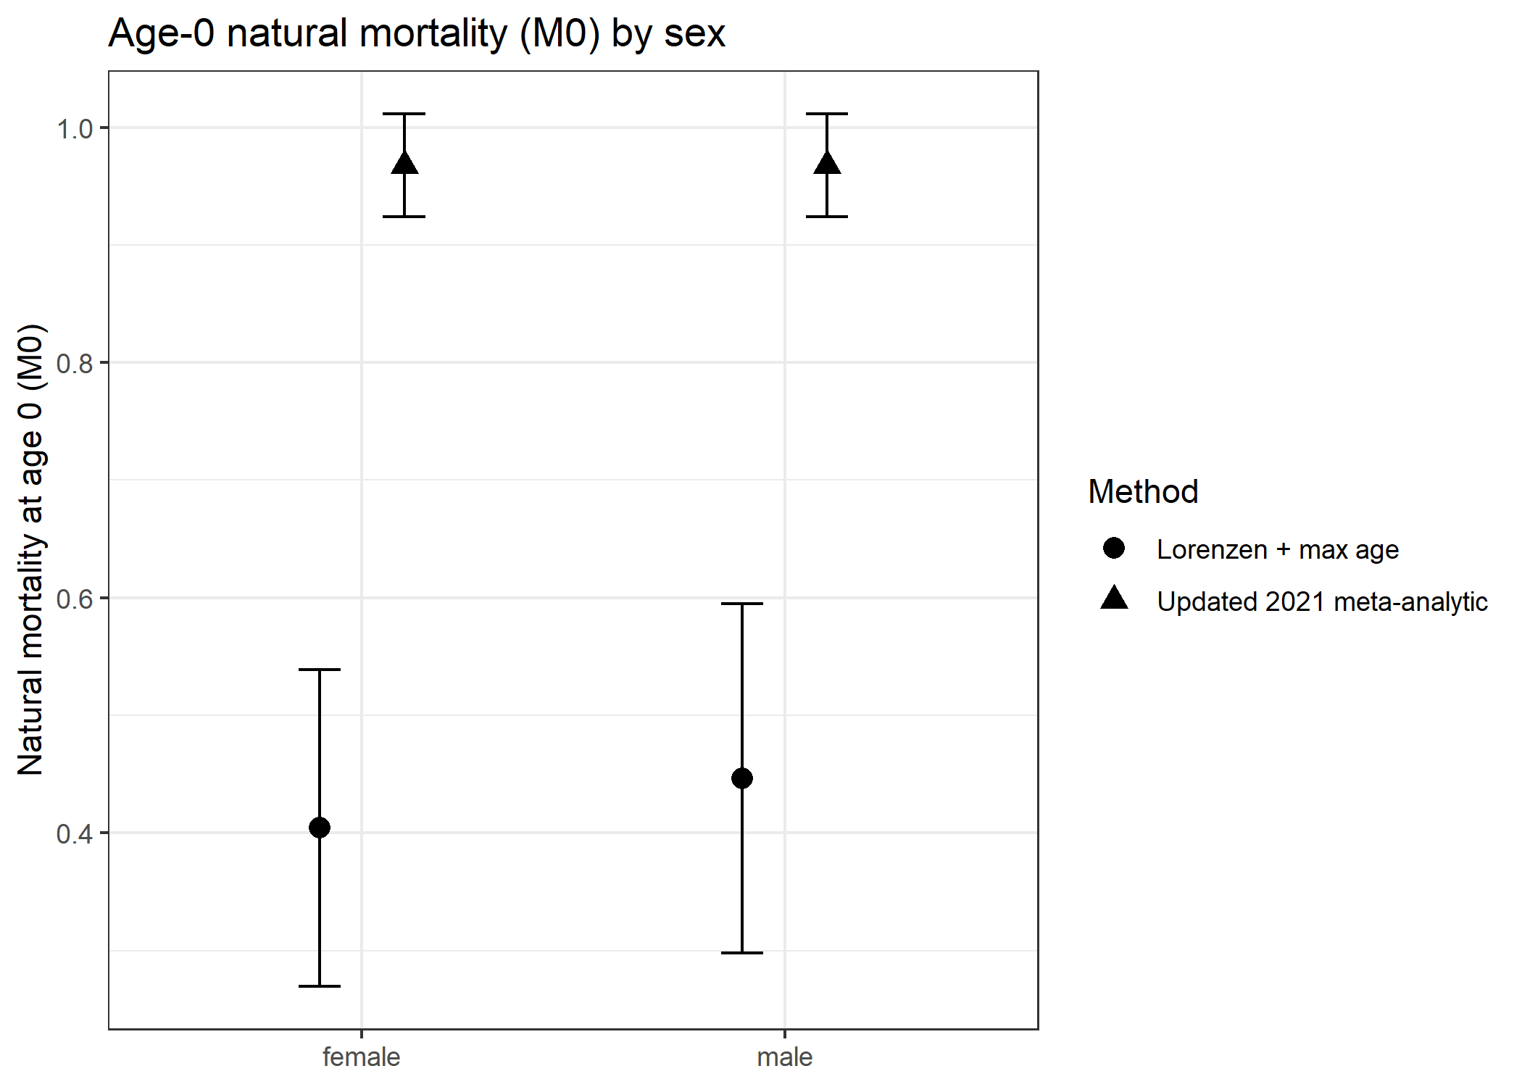

Figure 11. Comparison of Lorenzen-scaled maximum age based and meta analytic estimates of natural mortality at age-1 to age-30 by sex for Pacific blue marlin.
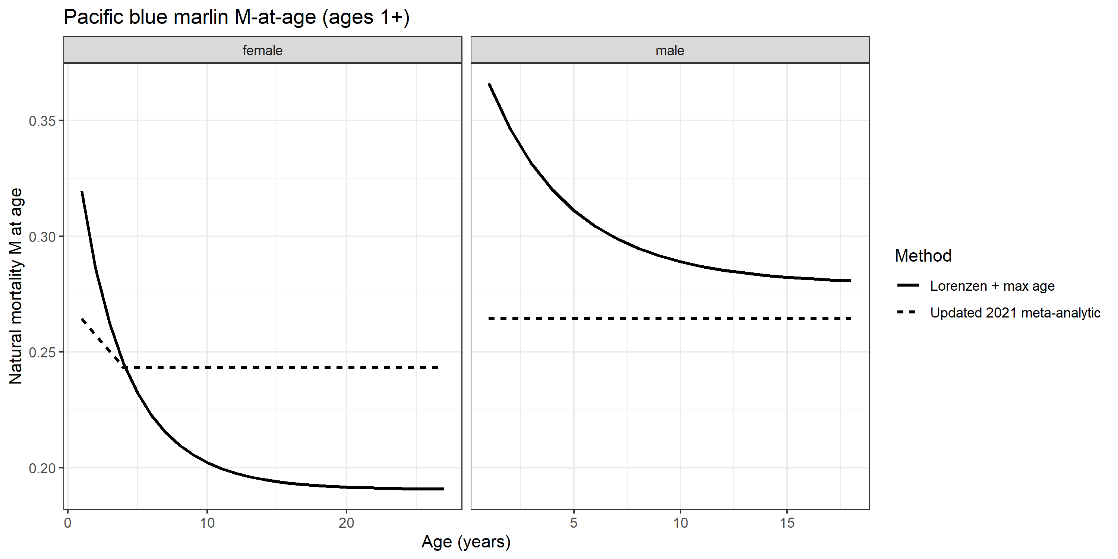

Figure 12. Results of sensitivity analysis of M-at-age to maturity-ogive based adult window set by A₅₀ (top panel) and A₉₅ (bottom panel).
